Category: A. Received Signal Strength Estimation / B. Flexible Antenna Design (Choose One)
Name of the Team for ISAP2025 SDC

First Member¹, e-mail address
Second Member¹, e-mail address
Third Member¹, e-mail address
Fourth Member², e-mail address
Mentor: Mentor’s name³, e-mail address (if any)
¹First Department, First University, Address including country name
²Second Department, Second University, Address including country name
³Third Company, Address including country name

Abstract - Please include a brief abstract here. The abstract should be limited to within 200 words and should concisely state what was done, how it was done, principal results, and their significance.
- INTRODUCTION
Please describe an introduction of your design briefly.
- DESCRIPTION OF EACH CATEGORY
The team must submit this application form to the ISAP 2025 Student Design Contest (SDC) secretariat via E-mail (isap-sdc2025@mail.ieice.org) by June 27, 2025. This file is a template of application form, which summarizes a preliminary design or a proposal of your team. In addition to this form, all teams should prepare the confirmation letter provided by the supervisor to verify that all team members are full-time students at a university, college, or technical school and agree to the team’s participation in the SDC. See the following detailed instructions for each category when making the application form. The application form must be submitted in A4-sized PDF format up to 2 pages (excluding the confirmation letter).
Category A. Received Signal Strength Estimation
Participants will be asked to estimate the received signal strength at the estimated target points based on the information on the environment, transmission position, transmitter, and received power at the reference point that will be distributed in advance.
The following information will be distributed in advance to those who wish to participate.
- General materials of walls, etc. in the measurement environment.
- Position and height of each point (transmitter, reference points, estimated target points)
- Received signal strength at the reference points (results measured in advance by the secretariat)
Participants should build an estimation model based on the distributed information and include it in the manuscript. The following can be included.
- Multiple patterns of estimation results or estimation models according to the environmental conditions
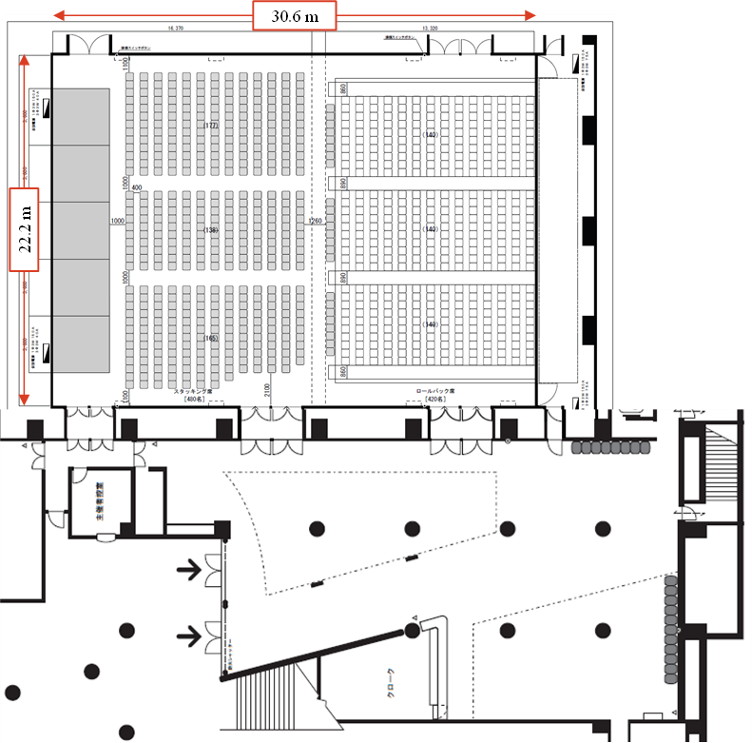

Fig. 1 Floor map for measurements.
- Adjustment parameters according to the environmental conditions (for example, attenuation terms according to the number of people)
The received power at the estimated target points will be measured in front of the participants on the day of the contest. The arrangement of fixtures and the congestion of people at the time of measurement on the day of the contest may differ from the environmental conditions distributed in advance. Please observe the measurement situation and determine the final estimated values based on the estimation models described in the manuscript.
The estimated errors between the estimated values ​​submitted on the day of the contest and the actual measured values ​​will be evaluated, and the participant with the smallest error will be declared the winner.
The key to estimating received signal strength with high accuracy is to build an adjustable estimation model using information distributed in advance (or prepare multiple patterns of estimation results/estimation models depending on the situation), and to adjust the model based on the conditions at the time of measurement on the day of the contest.
The map of the measurement environment is shown in Fig.1. Please refer to it for the estimation of the environment.
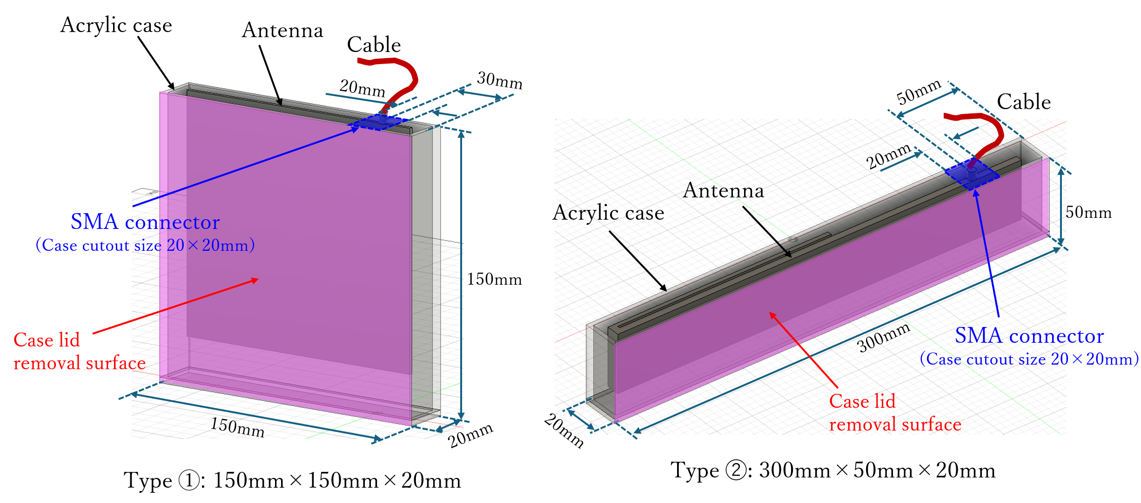

Fig. 2 Structure of acrylic cases.

Category B. Flexible Antenna Design
Design an antenna to receive broadcast waves (FM radio) that satisfies the following specifications.
A part or all of the radiating elements of the designed antenna should be flexible in shape. The design frequency of the antenna is 90.0MHz. The antenna should fit into two different sized acrylic cases:
- Type 1: 150mm×150mm×20mm
- Type 2: 300mm×50mm×20mm.
Fig. 2 shows the structure of the two types of acrylic cases. Each case has a cutout for the SMA cable (characteristic impedance of 50Ω). The antenna consists of passive materials only. Do not use active components such as amplifiers. Only one type of antenna will be designed. Also, there will be only one feeding point. The antenna shape needs to be changed to fit into each size case. A SMA female connector should be attached to the antenna for feeding. The connector is included with the antenna size specified above. Measured and simulated results of the designed antenna must be included in the submitted application form. The document should include the following information:
- Description of the antenna design
- Geometry
- Simulated reflection coefficient (S₁₁)
- Simulated Efficiency
- Simulated Gain

- EXAMPLES OF EQUATION, TABLE, AND FIGURE
a + b = c (1)
TABLE I A TABLE EXAMPLE
Event | Date
Deadline for SDC Application | June 27, 2025
Notification of Finalists | July, 2025
Deadline for SDC Registration of Finalists | August 2025 (TBD)
On-site Competition | October, 2025

- CONCLUSION
Thank you for your contribution to the ISAP 2025 Student Design Contest.
ACKNOWLEDGMENT
Insert acknowledgment, if any.
REFERENCES
- A. Maxwell, “Antennas and propagation for ISAP 2025,” IEICE Trans. Commun., vol. E99-B, no. 1, pp. 101-112, Jan. 2025.
- B. C. Faraday, Book for ISAP 2025. Wiley: New York, 2003, pp.68-73.
- D. E. Gauss, “Mobile antennas for ISAP 2025,” Microwave Opt. Technol. Lett., vol. 51, pp. 190-194, 2009.
- F. Ampere, “EM wave theory in ISAP 2025,” in Proc. International Symposium on Antennas and Propagation (ISAP), 2012, Nagoya, Japan, pp. 100-101.
- G. Maxwell, “Antennas and propagation in ISAP 2025,” in Proc. IEEE Antennas Propagat. Soc. Int. Symp., 2012, Orlando, FL, USA, pp. 100-101.
- H. Faraday, “Title of paper,” unpublished.
- I. Green, “Title of paper,” IEEE Trans. Antennas Propagat., in press.

